Extra 20-1 Use the default authentication of the Web Forms template

In this exercise, you’ll create a web application using the Web Forms template. Then, you’ll review and test the authentication system that’s part of this template by default to see how it works.

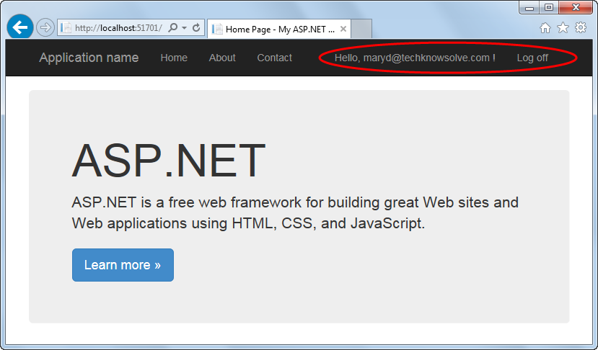

Create and review a web application using the Web Forms template

1. Start a new web application named XEx20Authentication in your exercises_extra folder. Make sure you use the Web Forms template rather than the Empty template you’ve used in previous exercises.
2. Review the Project_Readme.html page that’s displayed in the internal browser after the application is created. Then, click the Authentication link in the left column and review the information on the page that’s displayed. When you’re done reviewing this information, press the Backspace key on your keyboard to return to the previous page and then close the browser tab.
3. Expand the App_Start directory in the Solution Explorer, and review the code in the IdentityConfig.cs and Startup.Auth.cs files.
4. Expand the Account directory, and review the aspx and code-behind files for the Register and Login pages.
5. Review the aspx code for the navbar in the master page that’s located in the root directory. In addition, review the code in the Startup.cs file in the root directory.

Run the application and register one or more users

1. Run the application and click the Register link in the navbar of the page that’s displayed to display the Register page. Register a user (be sure to make a note of the email and password you choose) and notice how the navbar changes. Then, log off and see how the navbar changes again.
2. Click the Log in link in the navbar to display the Login page, and log in as the user you created in step 6. Then, click on the greeting that’s displayed in the navbar to display the Manage Account page.
3. Click on the Change link for the password to go to the Manage Password page. Then, change the password for the user (as before, be sure to make a note of the new password). Note the query string in the URL and the notification at the top of the Manage Account page telling you that your password was changed successfully.
4. Open the code-behind file for the Manage.aspx page in the Accounts directory. Review the code near the end of the Load event handler to see how the page uses the value of the query string to determine the notification that’s displayed to the user.

Change the default requirements for a password

1. Log off, navigate back to the Register page, and add a second user. Use a different email address than in step 6 and the password “p2ssw0rd”.
2. Review the notification that tells you that the password doesn’t meet certain requirements, and make a note of what those requirements are. Then, close the browser.
3. Open the IdentityConfig.cs file in the App_Start directory, and find the static Create method in the ApplicationUserManager class that contains configuration code for the password. Adjust the RequireNonLetterOrDigit and RequireUppercase properties so the password you entered in step 10 will be accepted.   
     
   **Submit Screen shot of what you changed.**
4. Run the application and repeat step 10 to confirm that this works.